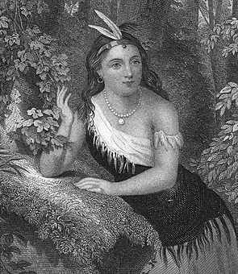

**Christopher Columbus made his famous voyage**

**Pocahontas**

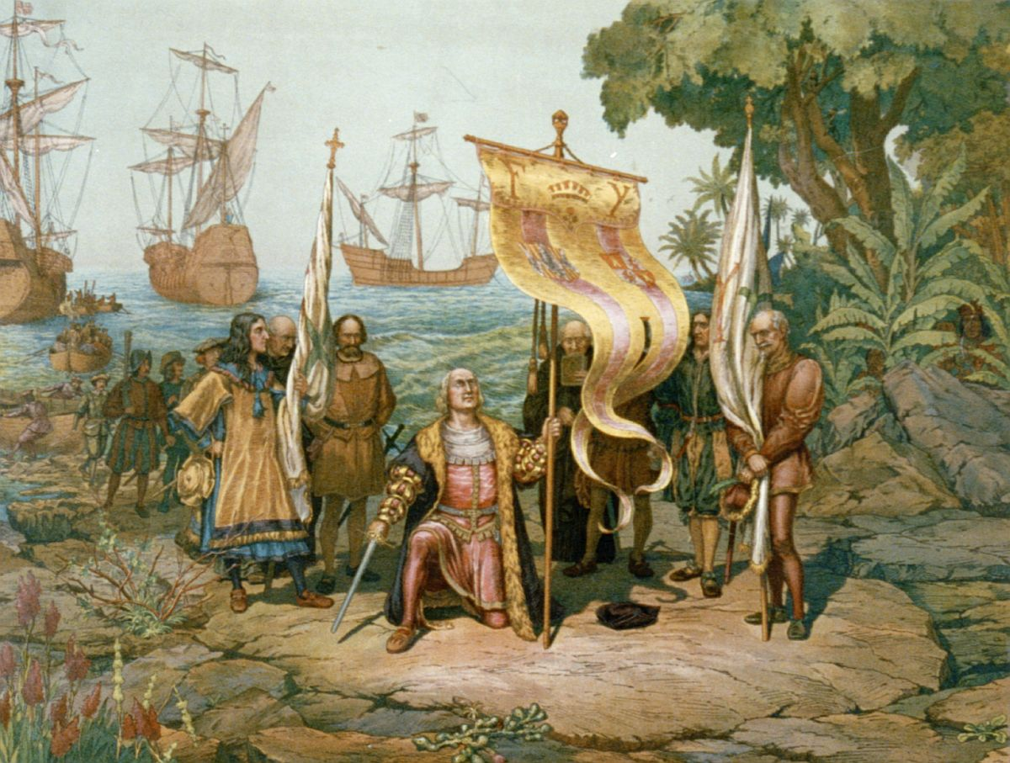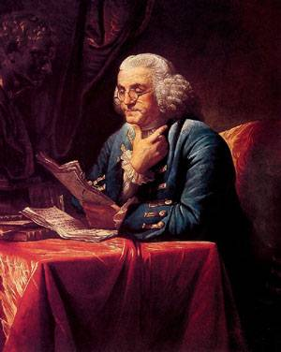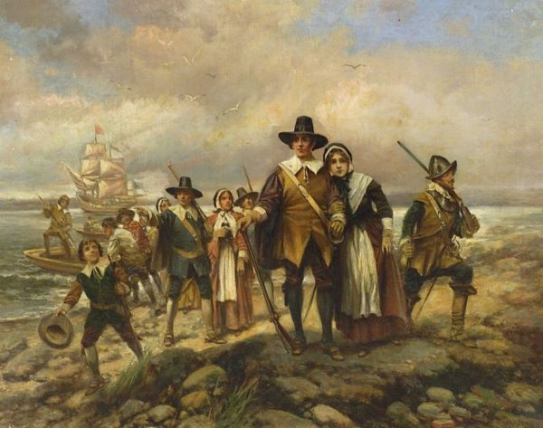

**1492**

http://www.learnnc.org/lp/multimedia/6267

**Born in the late 1500’s**

http://www.time.com/time/magazine/article/0,9171,1615189,00.html

Image taken from Google Images

**1620**

Image taken from Google Images

**Born in 1706**

**Benjamin Franklin**

**The Pilgrims came to America on the Mayflower**

**Paul Revere**

**George**

**Washington**

**Born in 1735**

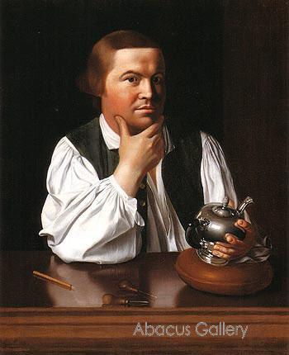

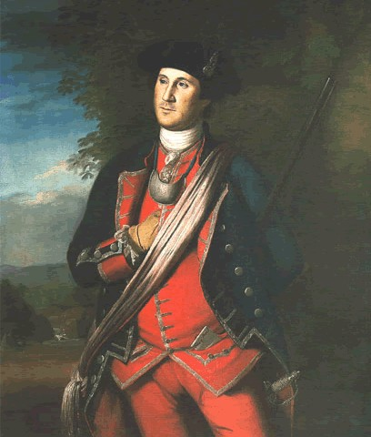

**Born in 1732**

Image taken from Google Images

Image taken from Google Images

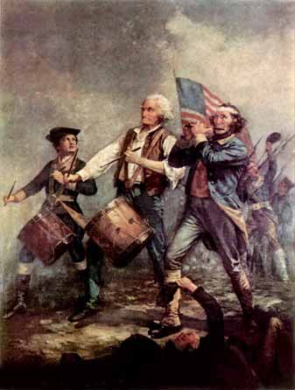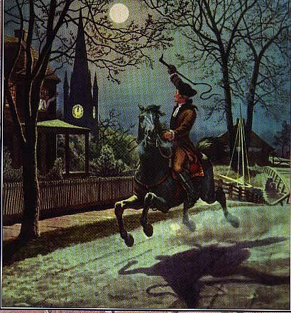

**1775**

Image taken from Google Images

**Revolutionary War begins**

**1775**

Image taken from Google Images

**Paul Revere warned the Americans that the British were coming**

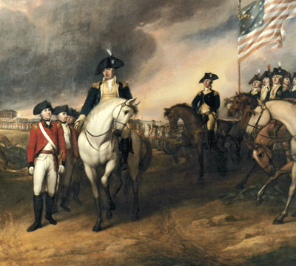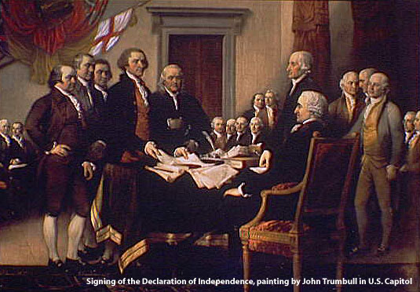

**1783**

Image taken from Google Images

**Revolutionary War ends**

**July 4, 1776**

Image taken from Google Images

**The Declaration of Independence is signed**

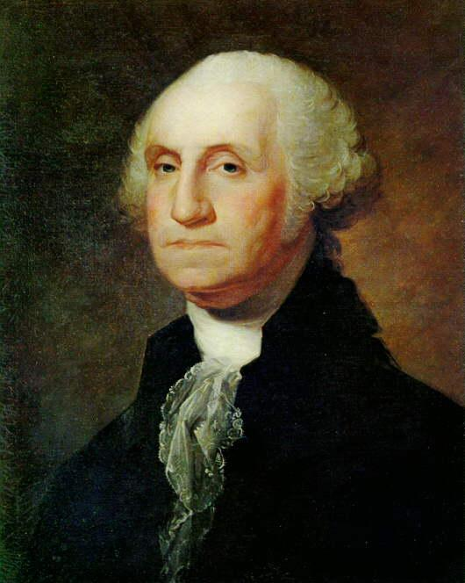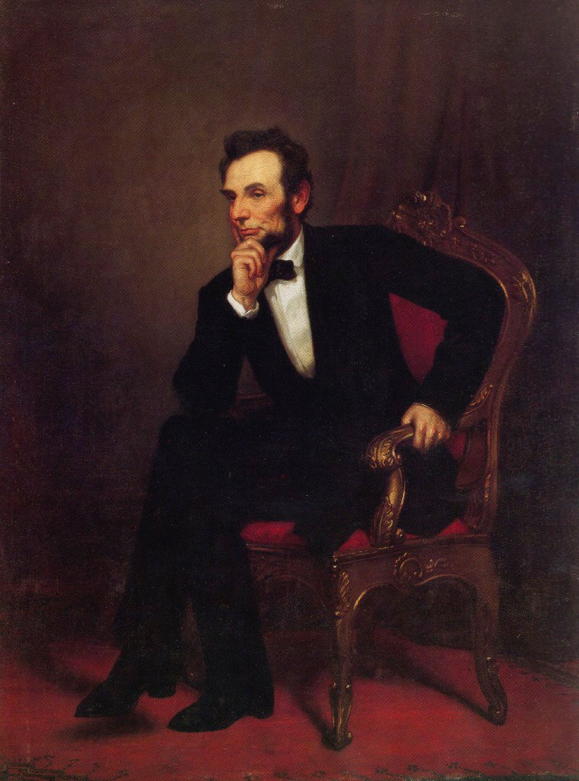

**Born in 1809**

**1789**

Image taken from Google Images

**George Washington becomes the 1st President of the United States**

Image taken from Google Images

**Abraham Lincoln**

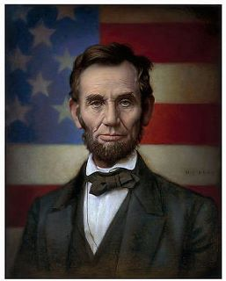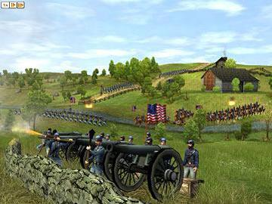

**1860**

Image taken from Google Images

**Civil War begins**

Image taken from Google Images

**1861**

**Abraham Lincoln becomes the 16th President of the United States**

**Slaves are FREE**

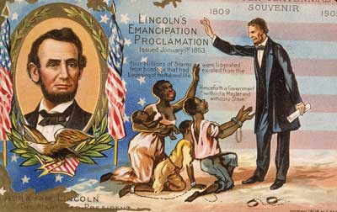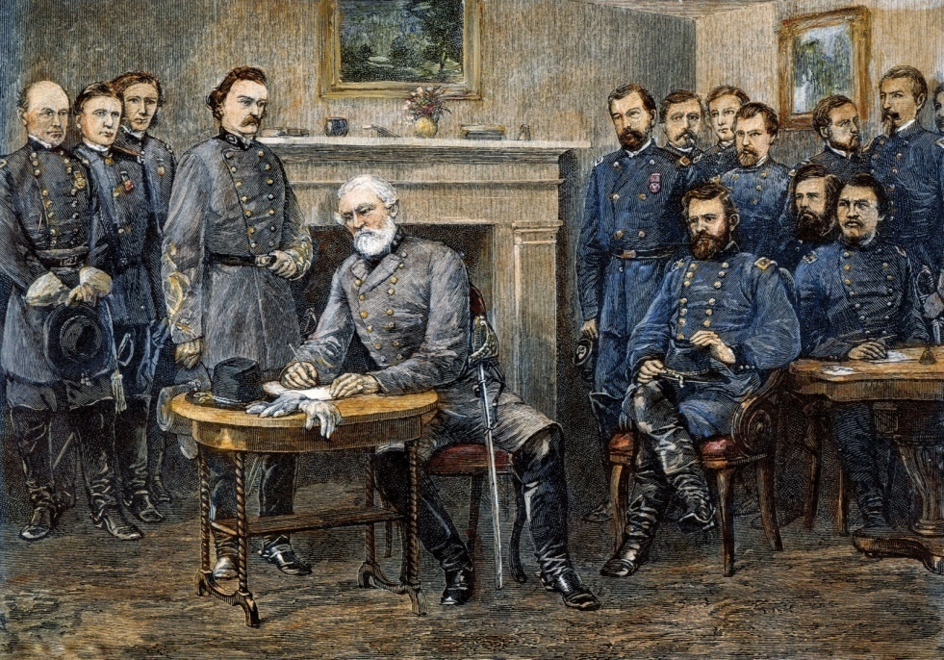

Image taken from Google Images

**1863**

**Civil War ends**

Image taken from Google Images

**1865**

Image taken from Google Images

**Laura Ingalls Wilder**

**George Washington Carver**

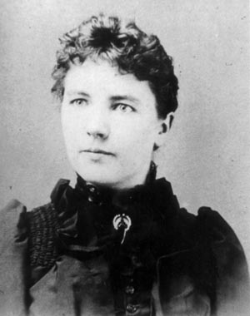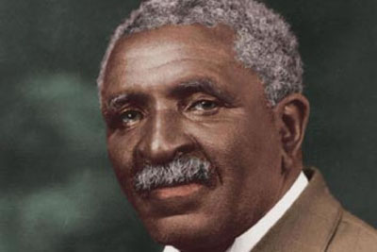

**Born in 1867**

Image taken from Google Images

**Born 1864 or 1865**

Image taken from Google Images

**Thomas Alva Edison**

**Jackie Robinson**

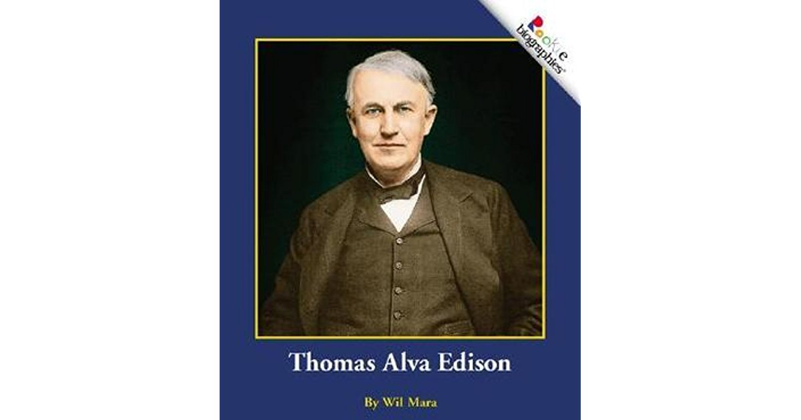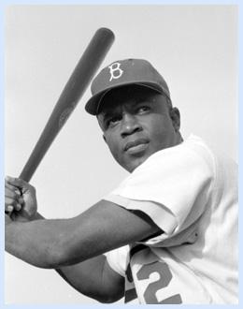

Image taken from Google Images

**Born in 1847**

Image taken from Google Images

**Born in 1919**